RIX 2024 - Batch 1- NUnit & Jest Practical Assessment Assessment

12576 Nisanth Saravanan

Online Courier Management System

An online courier management system is a software application that is used to manage the process of sending and tracking packages and documents through a courier service. This typically includes functions such as creating shipping labels, tracking packages, and generating reports. This project is a useful tool for businesses and individuals who need to send packages and documents through a courier service on a regular basis.

W3H Analysis

Project Title: Online Courier Management System
What? |  | How?
1. What are the necessary modules?  A: Modules Needed:  1) Login and Registration.  2) Admin Dashboard.  3)User Dashboard.  2. What are the necessary functionalities of Login and Registration Modules?  A: Login and Registration Module:  1) Register User.  2) Login as User.  3) Login as Admin.  3. What are the necessary functionalities of Admin Dashboard?  A: Admin Dashboard:  1) Perform CRUD Operation with Shipments.  2) Filter Shipments.  4. What are the necessary functionalities of User Dashboard?  A: User Dashboard:  1) Filter Shipments.  5. What are the tables needed?  A: Tables Required:  - Shipments  - Users  6. What are the fields of user table?  A: Fields of Users table:  - Id (Primary Key) - int  - Name – string  - Password – string  - Role – string  7. What are the fields of the Shipment table?  A: Fields of Shipment Table:  - Id (Primary Key) - int  - Name – string  - Type – string  - Address – string  8. What are the two values of the Role Field in the User table?  A: Admin Role  User Role  9. What are the must have dependencies?  A: Dependencies:  - axios  - react-router-dom  - toastr  10. What are the validations in the application?  A: Overall validations list:  - Frontend simple JS Validations.  - Server Side validations.  - Form Validations. |  | Login and Registration Module:  1) Register User:  Method 1: Use Simple Form Page.  Method 2: Use a Modular Form Page.  Method 3: Use Google OAuth and other 3rd party services.  2) Login as User:  Method 1: Use Simple Form.  Method 2: Use a Modular Form.  Method 3: Use 3rd party services.  3) Login as Admin:  Method 1: Hard Code the Admin accounts.  Method 2: Have an Admin Login Page.  Method 3: Have a separate Register + Login for admins.  Admin Dashboard:  1) Perform CRUD Operation with Shipments:  Method 1: Use Simple Forms and Buttons to perform CRUD.  Method 2: Have separate pages for each operation  Method 3: Use Modals.  2) Filter Shipments:  Method 1: Use a simple search bar.  Method 2: Have tables and sorting buttons.  Method 3: Have a separate page to pick out exact results.  User Dashboard:  1) Filter Shipments:  Method 1: Use a simple search bar.  Method 2: Have tables and sorting buttons.  Method 3: Have a separate page to pick out exact results.
Login and Registration Module:  1) Register User:  Method 1: Use Simple Form Page.  A: Since the overall scale of the application is small and data needed is rather minimal, it’s wise to stick with traditional forms.  2) Login as User:  Method 1: Use Simple Form.  A: Since the overall scale of the application is small and data needed is rather minimal, it’s wise to stick with traditional forms.  3) Login as Admin:  Method 1: Hard Code the Admin accounts.  A: It’s best to hard code admin users to ensure security and have only one or two admin users in total.  Admin Dashboard:  1) Perform CRUD Operation with Shipments:  Method 1: Use Simple Forms and Buttons to perform CRUD.  A: Since the overall scale of the application is small and data needed is rather minimal, it’s wise to stick with traditional forms.  2) Filter Shipments:  Method 1: Use a simple search bar.  A: Effective as it may, the simple input field can be directly mapped with the shipments that are being displayed.  User Dashboard:  1) Filter Shipments:  Method 1: Use a simple search bar.  A: Effective as it may, the simple input field can be directly mapped with the shipments that are being displayed. |  | Login and Registration Module:  1) Register User:  Method 2: Use a Modular Form Page.  A: Increases the complexity of the app, and also the fact that the number of needed inputs in rather minimal.  Method 3: Use Google OAuth and other 3rd party services.  A: Valid method but due to the scale of the application, this method is seemingly overkill.  2) Login as User:  Method 2: Use a Modular Form.  A: Increases the complexity of the app, and also the fact that the number of needed inputs in rather minimal.  Method 3: Use 3rd party services.  A: Valid method but due to the scale of the application, this method is seemingly overkill.  3) Login as Admin:  Method 2: Have an Admin Login Page.  A: Best not to have an admin login page distinctively when the primary user of the app is regular customers.  Method 3: Have a separate Register + Login for admins.  A: This increases the number of pages to be developed and also leaves open a vulnerable endpoint for someone to register as administrator.  Admin Dashboard:  1) Perform CRUD Operation with Shipments:  Method 2: Have separate pages for each operation.  A: Since the admin needs all information in one place and also that the number of operations they can do is limited, it is best to have a single page control centre type.  Method 3: Use Modals.  A: Seeing that the number of input fields are minimal, and asking for user input using modals is seemingly overkill.  2) Filter Shipments:  Method 2: Have tables and sorting buttons.  A: This method is also viable but not selected due to the slight increase in the number of code needed for its execution.  Method 3: Have a separate page to pick out exact results.  A: Having the all the data displayed in one page and search functionality in another is not idle. Hence, this method is rejected.  User Dashboard:  1) Filter Shipments:  Method 2: Have tables and sorting buttons.  A: This method is also viable but not selected due to the slight increase in the number of code needed for its execution.  Method 3: Have a separate page to pick out exact results.  A: Having the all the data displayed in one page and search functionality in another is not idle. Hence, this method is rejected.
Why? |  | Why Not?

Output Screenshots

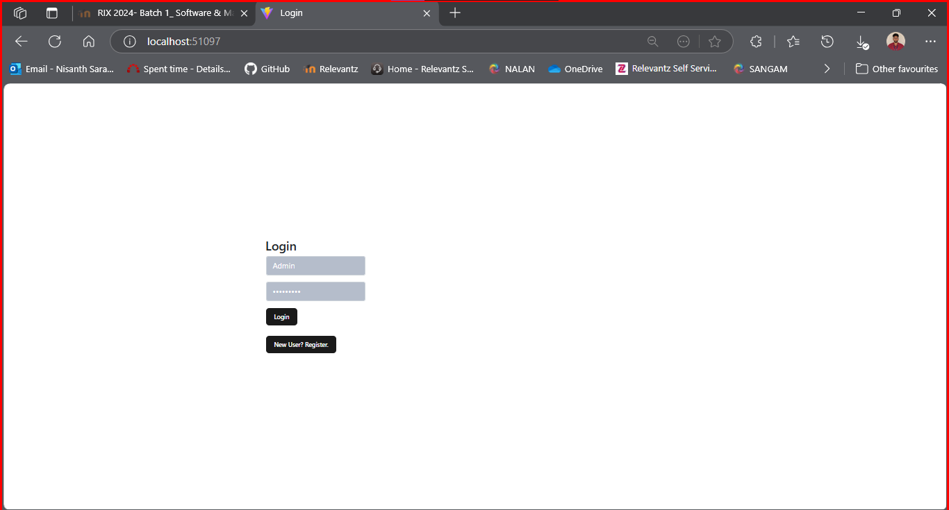

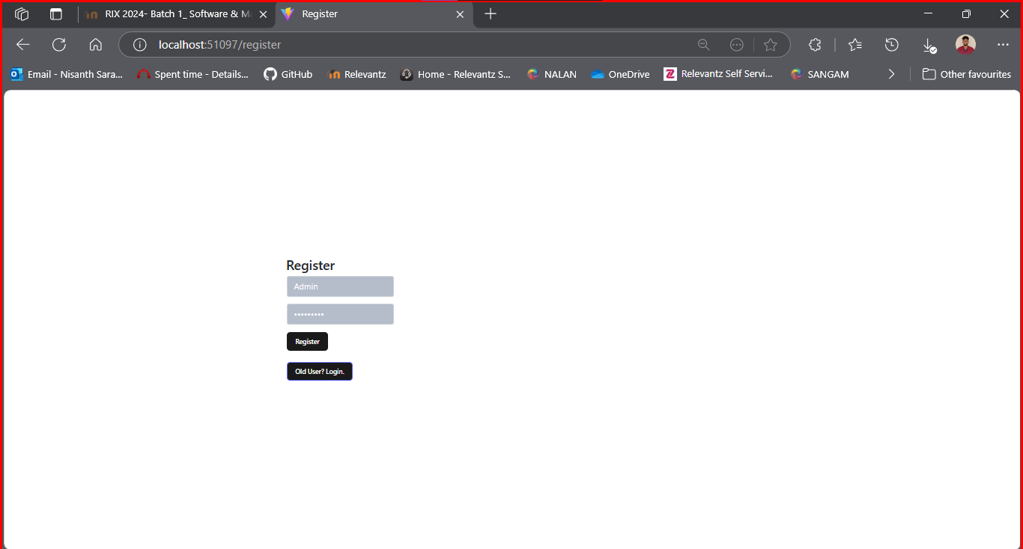

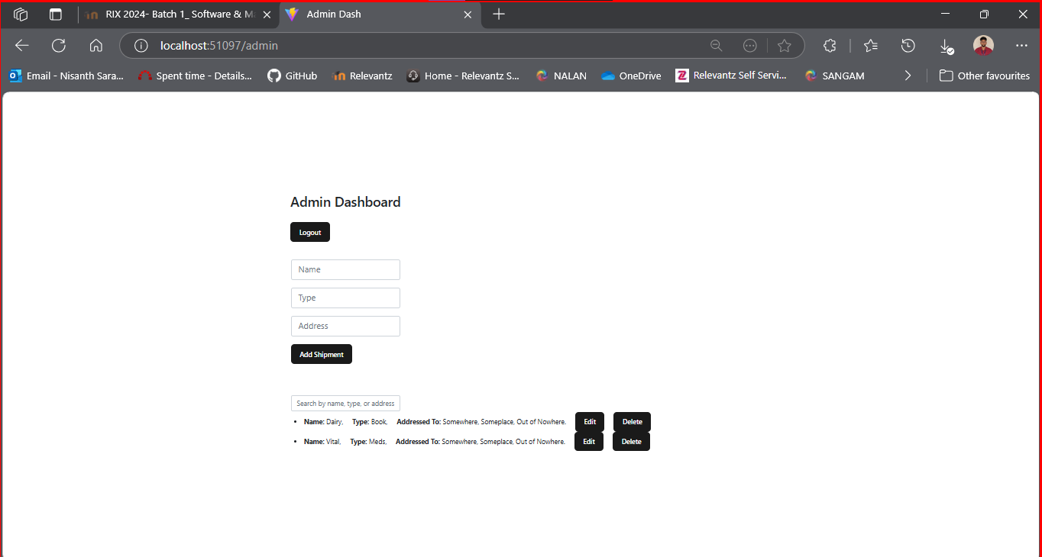

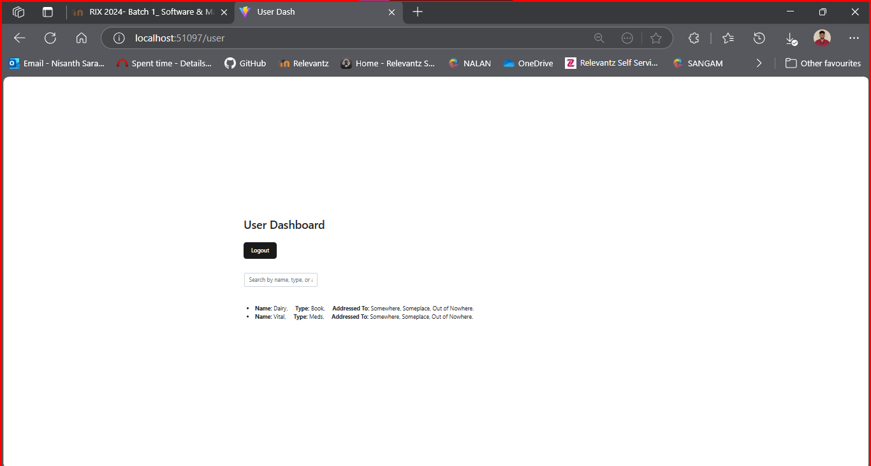
Testing:

Full File:

Nunit Testing:

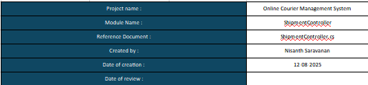

Setup

[SetUp]
public void Setup()
{
var options = new DbContextOptionsBuilder<AppDbContext>()
.UseInMemoryDatabase("TestDb")
.Options;

_context = new AppDbContext(options);
_controller = new ShipmentController(_context);
}

Tear Down

[TearDown]
public void TearDown()
{
_context.Database.EnsureDeleted();
_context.Dispose();
}
Usings

using Microsoft.AspNetCore.Mvc;
using Microsoft.EntityFrameworkCore;
using ShipmentManagementWebApi.Data;
using ShipmentManagementWebApi.Models;
Final Nunit Testing Output

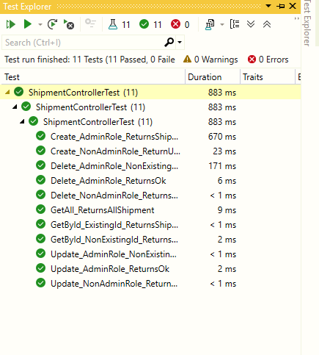
GetAll_ReturnsAllShipment()

[Test]
public void GetAll_ReturnsAllShipment()
{
//Arrange
var shipment = new Shipment
{
Id = 1,
Name = "Box A",
Type = "Electronics",
Address = "123 Avenue"
};
_context.Shipments.Add(shipment);
_context.SaveChanges();

//Act
var result = _controller.GetAll() as OkObjectResult;

//Assert
Assert.IsNotNull(result);
Assert.IsInstanceOf<OkObjectResult>(result);
Assert.IsNotNull(result.Value);
Assert.IsInstanceOf<List<Shipment>>(result.Value);
Assert.AreEqual(1, ((List<Shipment>)result.Value).Count);
}

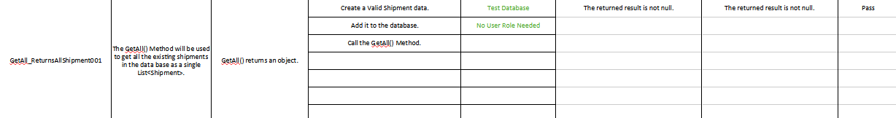
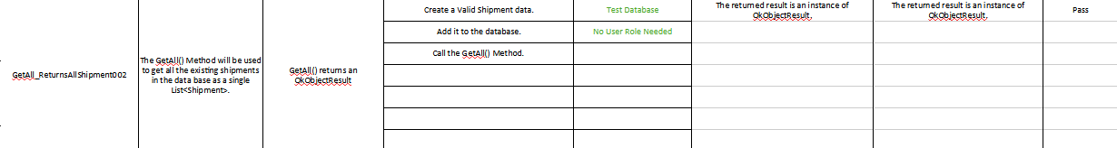
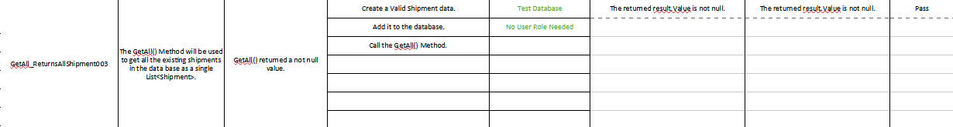
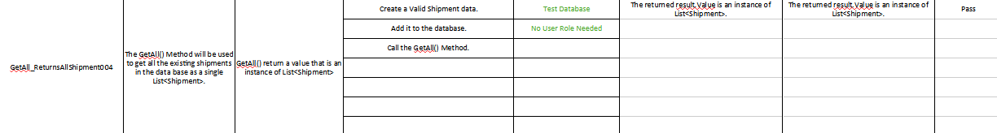
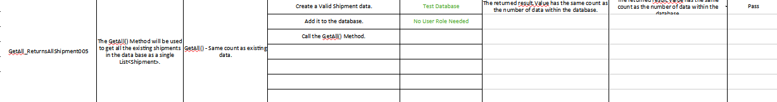
GetById_ExistingId_ReturnsShipment()

[Test]
public void GetById_ExistingId_ReturnsShipment()
{
//Arrange
var shipment = new Shipment
{
Id = 1,
Name = "Box A",
Type = "Electronics",
Address = "123 Avenue"
};
_context.Shipments.Add(shipment);
_context.SaveChanges();

//Act
var result = _controller.Get(1) as OkObjectResult;

//Assert
Assert.IsNotNull(result);
Assert.IsInstanceOf<OkObjectResult>(result);
Assert.IsNotNull(result.Value);
Assert.IsInstanceOf<Shipment>(result.Value);
Assert.AreEqual(shipment, result.Value);
}

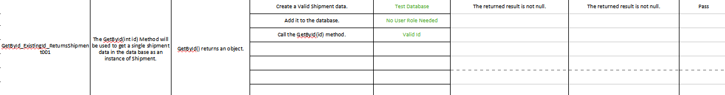
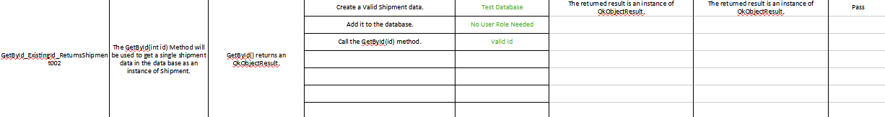
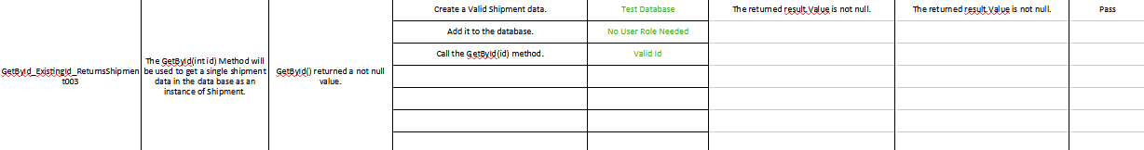
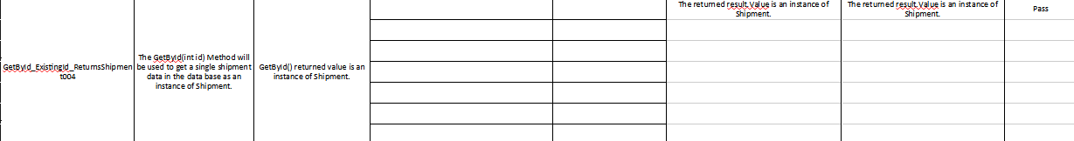
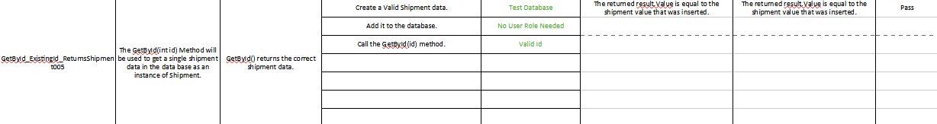
GetById_NonExistingId_ReturnsNotFound()

[Test]
public void GetById_NonExistingId_ReturnsNotFound()
{
//Act
var result = _controller.Get(1) as NotFoundObjectResult;

//Assert
Assert.IsNotNull(result);
Assert.IsInstanceOf<NotFoundObjectResult>(result);
Assert.IsNotNull(result.Value);
Assert.IsInstanceOf<String>(result.Value);
Assert.AreEqual("Shipment Not Found!", result.Value);
}

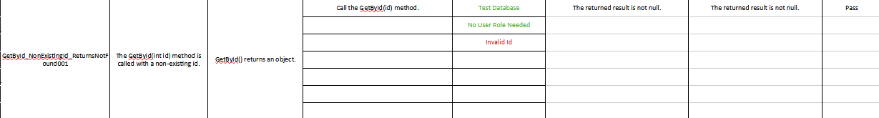
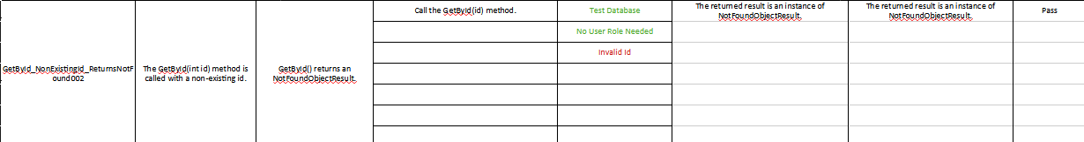
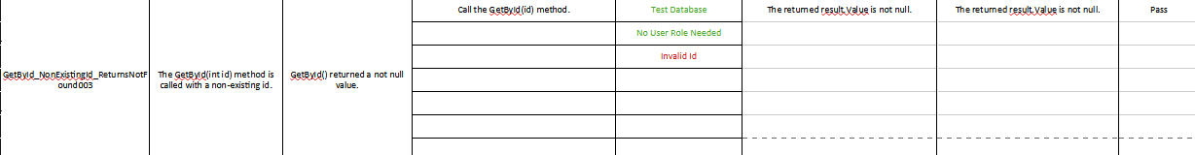
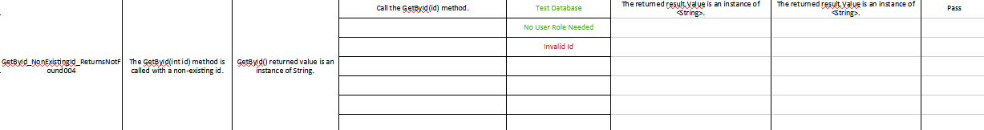
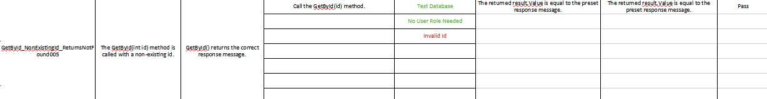
Create_AdminRole_ReturnsShipment()

[Test]
public void Create_AdminRole_ReturnsShipment()
{
//Arrange
var shipment = new Shipment
{
Id = 1,
Name = "Box A",
Type = "Electronics",
Address = "123 Avenue"
};

//Act
var result = _controller.Create(shipment, "Admin") as OkObjectResult;

//Assert
Assert.IsNotNull(result);
Assert.IsInstanceOf<OkObjectResult>(result);
Assert.IsNotNull(result.Value);
Assert.IsInstanceOf<Shipment>(result.Value);
Assert.AreEqual(shipment, result.Value);
}

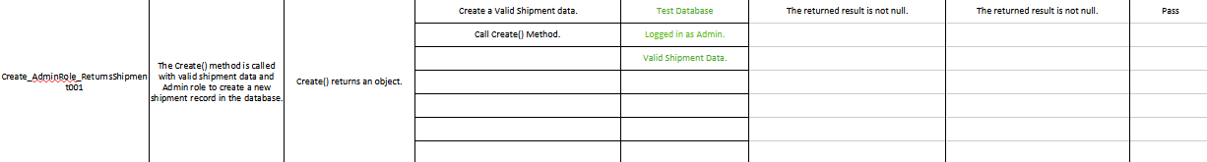
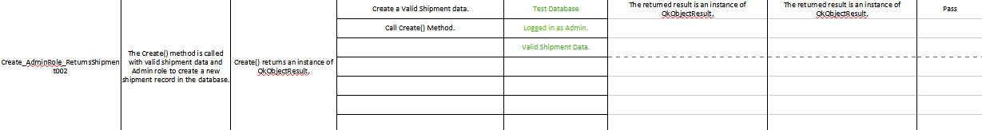
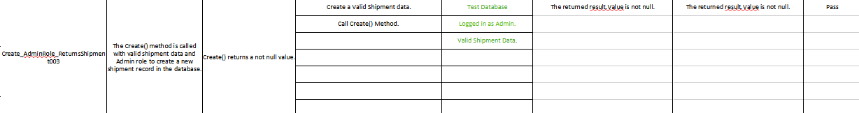
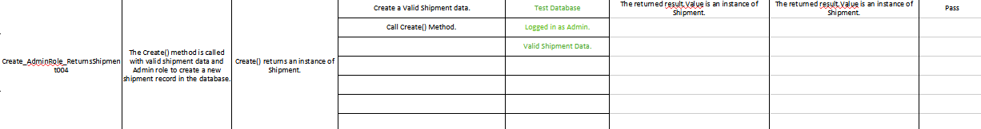
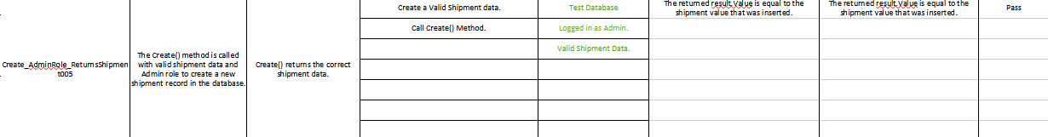
Create_NonAdminRole_ReturnUnauthorized()

[Test]
public void Create_NonAdminRole_ReturnUnauthorized()
{
//Arrange
var shipment = new Shipment
{
Id = 1,
Name = "Box A",
Type = "Electronics",
Address = "123 Avenue"
};

//Act
var result = _controller.Create(shipment, "User") as UnauthorizedObjectResult;

//Assert
Assert.IsNotNull(result);
Assert.IsInstanceOf<UnauthorizedObjectResult>(result);
Assert.IsNotNull(result.Value);
Assert.IsInstanceOf<String>(result.Value);
Assert.AreEqual("Only admin can create shipments", result.Value);
}

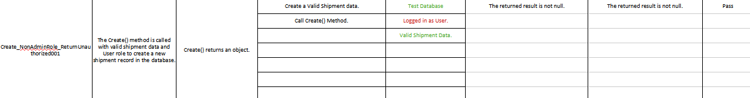
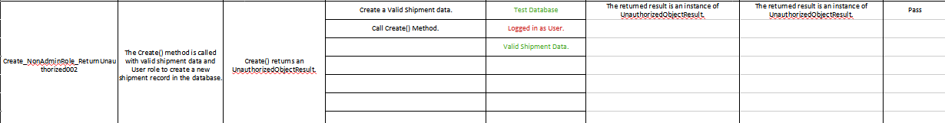
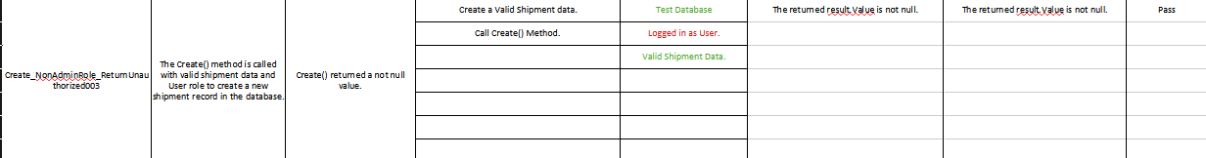
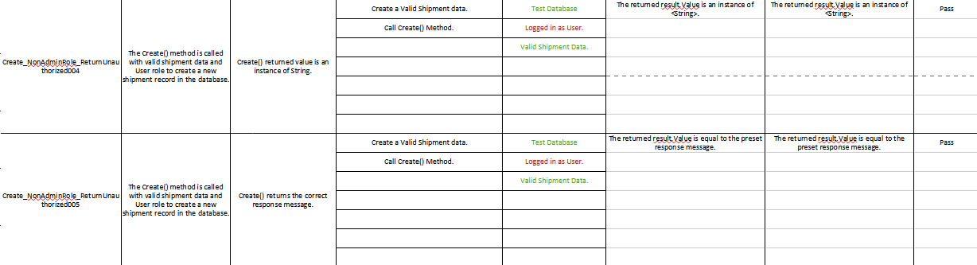
Update_AdminRole_ReturnsOk()

[Test]
public void Update_AdminRole_ReturnsOk()
{
//Arrange
var shipment = new Shipment
{
Id = 1,
Name = "Box A",
Type = "Electronics",
Address = "123 Avenue"
};
_context.Shipments.Add(shipment);
_context.SaveChanges();

var updatedShipment = new Shipment
{
Id = 1,
Name = "Box A",
Type = "Misc",
Address = "123 Avenue"
};

//Act
var result = _controller.Update(1, updatedShipment, "Admin") as OkObjectResult;

//Assert
Assert.IsNotNull(result);
Assert.IsInstanceOf<OkObjectResult>(result);
Assert.IsNotNull(result.Value);
Assert.IsInstanceOf<Shipment>(result.Value);
var resultingShipment = result.Value as Shipment;
Assert.AreEqual(updatedShipment.Type, resultingShipment.Type);
}
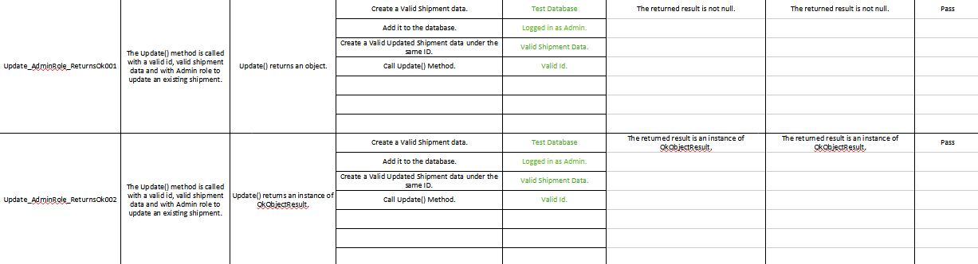
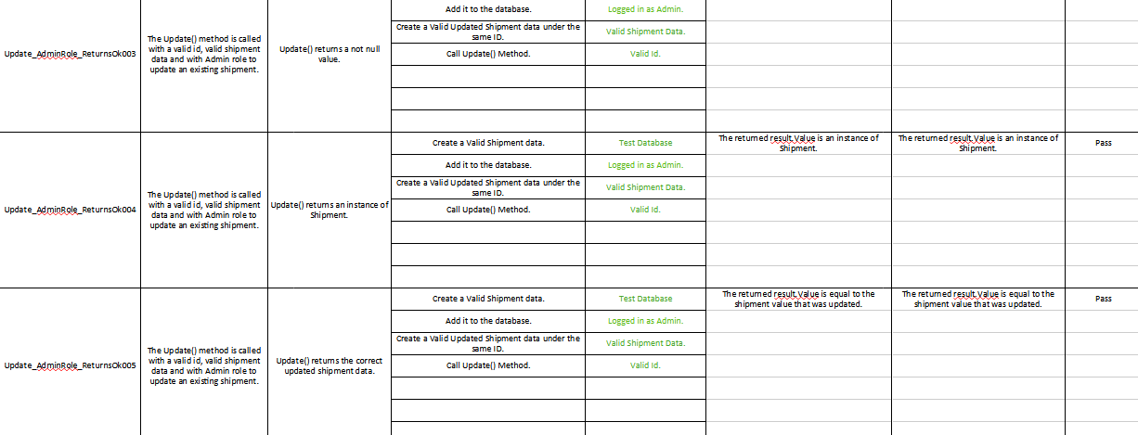
Update_NonAdminRole_ReturnsUnauthorized()[Test]
public void Update_NonAdminRole_ReturnsUnauthorized()
{
//Arrange
var shipment = new Shipment
{
Id = 1,
Name = "Box A",
Type = "Electronics",
Address = "123 Avenue"
};
_context.Shipments.Add(shipment);
_context.SaveChanges();

var updatedShipment = new Shipment
{
Id = 1,
Name = "Box A",
Type = "Misc",
Address = "123 Avenue"
};

//Act
var result = _controller.Update(1, updatedShipment, "User") as UnauthorizedObjectResult;

//Assert
Assert.IsNotNull(result);
Assert.IsInstanceOf<UnauthorizedObjectResult>(result);
Assert.IsNotNull(result.Value);
Assert.IsInstanceOf<String>(result.Value);
Assert.AreEqual("Only admin can update shipments", result.Value);
}

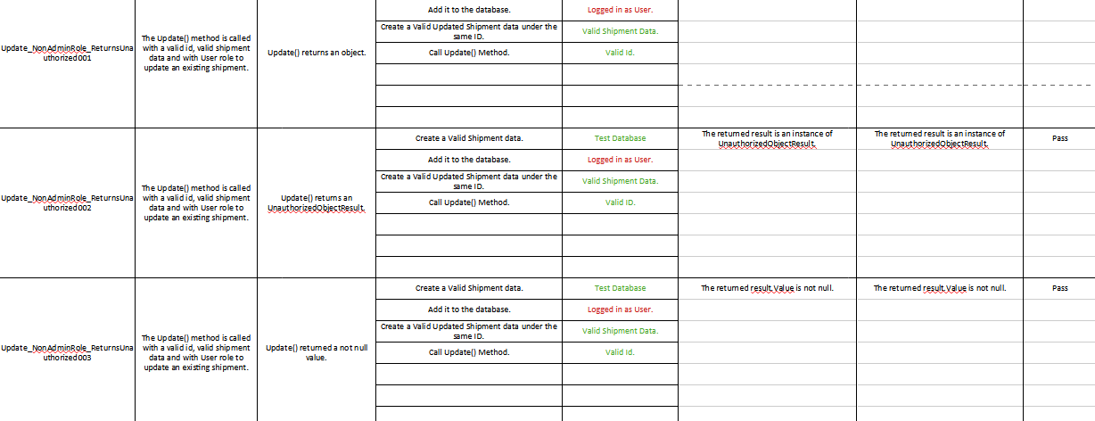
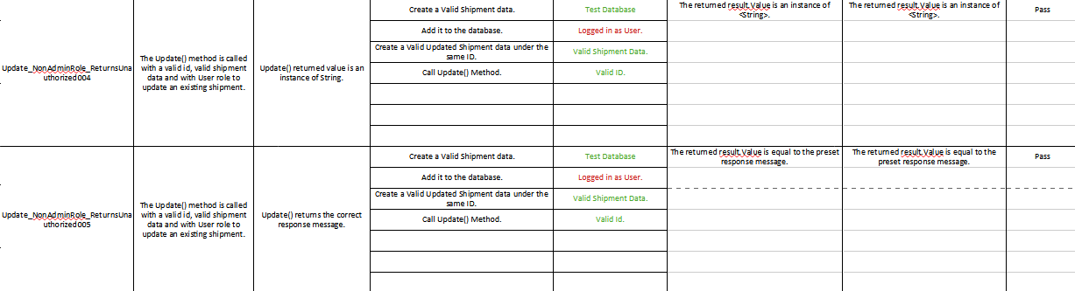
Update_AdminRole_NonExistingId_ReturnsNotFound()

[Test]
public void Update_AdminRole_NonExistingId_ReturnsNotFound()
{
//Arrange
var updatedShipment = new Shipment
{
Id = 1,
Name = "Box A",
Type = "Misc",
Address = "123 Avenue"
};

//Act
var result = _controller.Update(1, updatedShipment, "Admin") as NotFoundObjectResult;

//Assert
Assert.IsNotNull(result);
Assert.IsInstanceOf<NotFoundObjectResult>(result);
Assert.IsNotNull(result.Value);
Assert.IsInstanceOf<String>(result.Value);
Assert.AreEqual("Shipment Not Found!", result.Value);
}

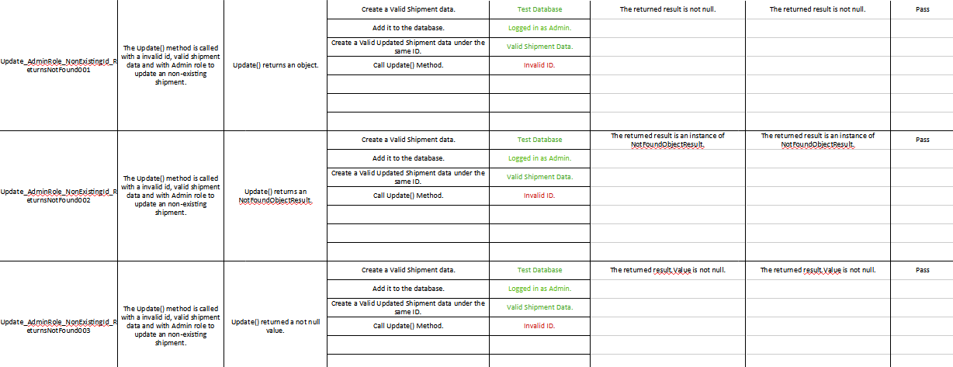
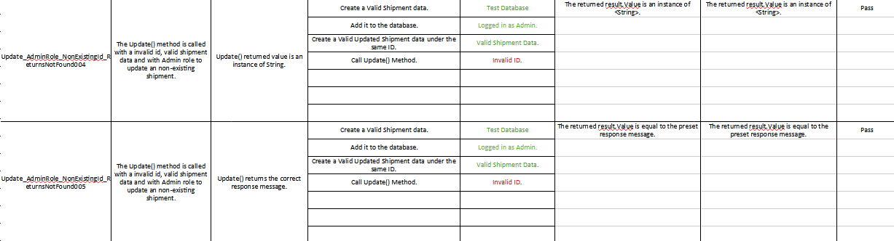
Delete_AdminRole_ReturnsOk()

[Test]
public void Delete_AdminRole_ReturnsOk()
{
//Arrange
var shipment = new Shipment
{
Id = 1,
Name = "Box A",
Type = "Electronics",
Address = "123 Avenue"
};
_context.Shipments.Add(shipment);
_context.SaveChanges();

//Act
var result = _controller.Delete(1, "Admin") as OkObjectResult;

//Assert
Assert.IsNotNull(result);
Assert.IsInstanceOf<OkObjectResult>(result);
Assert.IsNotNull(result.Value);
Assert.IsInstanceOf<String>(result.Value);
Assert.AreEqual("Deleted", result.Value);
}

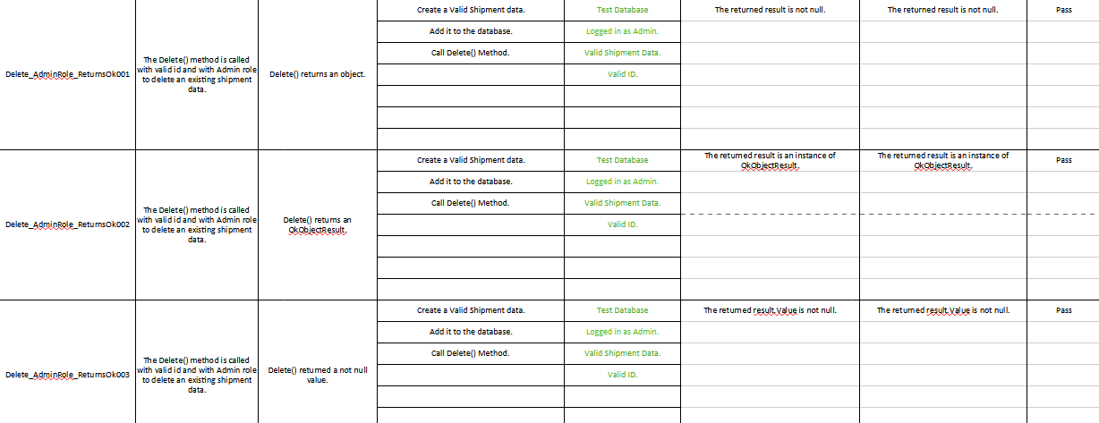
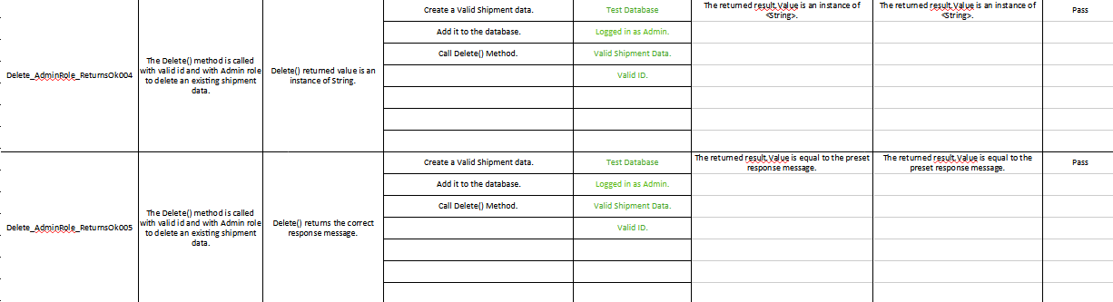
Delete_NonAdminRole_ReturnsUnauthorized()

[Test]
public void Delete_NonAdminRole_ReturnsUnauthorized()
{
//Arrange
var shipment = new Shipment
{
Id = 1,
Name = "Box A",
Type = "Electronics",
Address = "123 Avenue"
};
_context.Shipments.Add(shipment);
_context.SaveChanges();

//Act
var result = _controller.Delete(1, "User") as UnauthorizedObjectResult;

//Assert
Assert.IsNotNull(result);
Assert.IsInstanceOf<UnauthorizedObjectResult>(result);
Assert.IsNotNull(result.Value);
Assert.IsInstanceOf<String>(result.Value);
Assert.AreEqual("Only admin can delete shipments", result.Value);
}

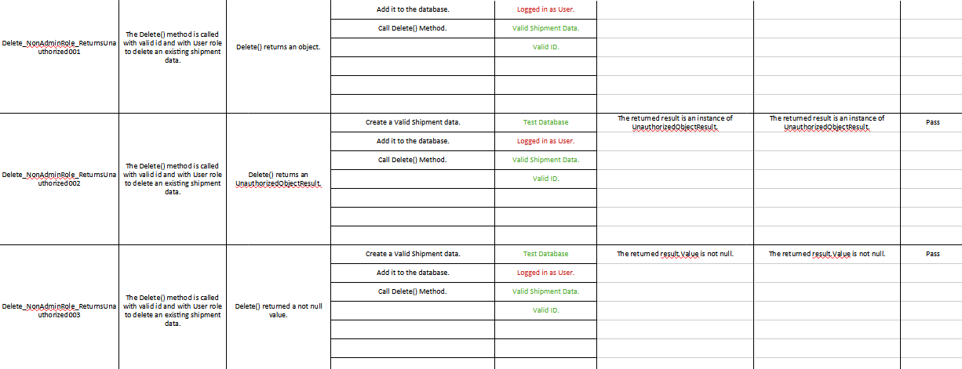
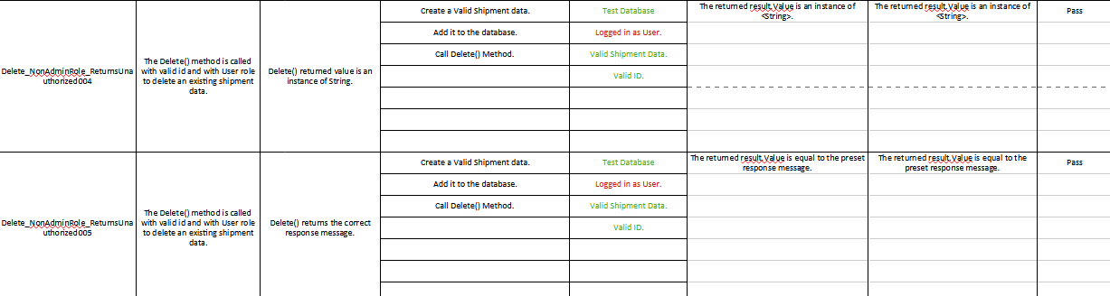
Delete_AdminRole_NonExistingId_ReturnsNotFound()

[Test]
public void Delete_AdminRole_NonExistingId_ReturnsNotFound()
{
//Act
var result = _controller.Delete(1, "Admin") as NotFoundObjectResult;

//Assert
Assert.IsNotNull(result);
Assert.IsInstanceOf<NotFoundObjectResult>(result);
Assert.IsNotNull(result.Value);
Assert.IsInstanceOf<String>(result.Value);
Assert.AreEqual("Shipment Not Found!", result.Value);
}

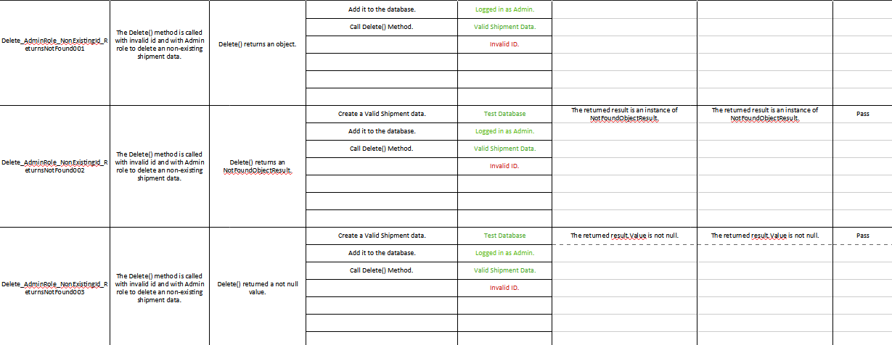
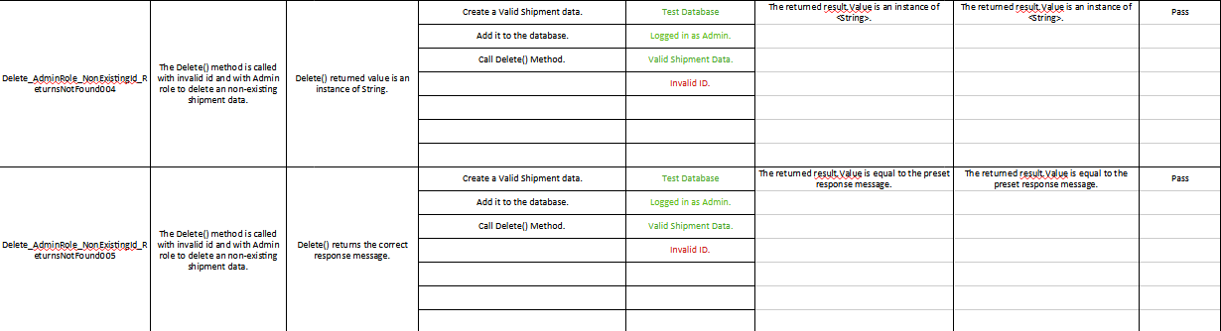
Full Nunit Testing Code

using Microsoft.AspNetCore.Mvc;
using Microsoft.EntityFrameworkCore;
using ShipmentManagementWebApi.Data;
using ShipmentManagementWebApi.Models;

namespace ShipmentControllerTest
{
[TestFixture]
public class ShipmentControllerTest
{
private AppDbContext _context;
private ShipmentController _controller;

[SetUp]
public void Setup()
{
var options = new DbContextOptionsBuilder<AppDbContext>()
.UseInMemoryDatabase("TestDb")
.Options;

_context = new AppDbContext(options);
_controller = new ShipmentController(_context);
}

[TearDown]
public void TearDown()
{
_context.Database.EnsureDeleted();
_context.Dispose();
}

[Test]
public void GetAll_ReturnsAllShipment()
{
//Arrange
var shipment = new Shipment
{
Id = 1,
Name = "Box A",
Type = "Electronics",
Address = "123 Avenue"
};
_context.Shipments.Add(shipment);
_context.SaveChanges();

//Act
var result = _controller.GetAll() as OkObjectResult;

//Assert
Assert.IsNotNull(result);
Assert.IsInstanceOf<OkObjectResult>(result);
Assert.IsNotNull(result.Value);
Assert.IsInstanceOf<List<Shipment>>(result.Value);
Assert.AreEqual(1, ((List<Shipment>)result.Value).Count);
}

[Test]
public void GetById_ExistingId_ReturnsShipment()
{
//Arrange
var shipment = new Shipment
{
Id = 1,
Name = "Box A",
Type = "Electronics",
Address = "123 Avenue"
};
_context.Shipments.Add(shipment);
_context.SaveChanges();

//Act
var result = _controller.Get(1) as OkObjectResult;

//Assert
Assert.IsNotNull(result);
Assert.IsInstanceOf<OkObjectResult>(result);
Assert.IsNotNull(result.Value);
Assert.IsInstanceOf<Shipment>(result.Value);
Assert.AreEqual(shipment, result.Value);
}

[Test]
public void GetById_NonExistingId_ReturnsNotFound()
{
//Act
var result = _controller.Get(1) as NotFoundObjectResult;

//Assert
Assert.IsNotNull(result);
Assert.IsInstanceOf<NotFoundObjectResult>(result);
Assert.IsNotNull(result.Value);
Assert.IsInstanceOf<String>(result.Value);
Assert.AreEqual("Shipment Not Found!", result.Value);
}

[Test]
public void Create_AdminRole_ReturnsShipment()
{
//Arrange
var shipment = new Shipment
{
Id = 1,
Name = "Box A",
Type = "Electronics",
Address = "123 Avenue"
};

//Act
var result = _controller.Create(shipment, "Admin") as OkObjectResult;

//Assert
Assert.IsNotNull(result);
Assert.IsInstanceOf<OkObjectResult>(result);
Assert.IsNotNull(result.Value);
Assert.IsInstanceOf<Shipment>(result.Value);
Assert.AreEqual(shipment, result.Value);
}

[Test]
public void Create_NonAdminRole_ReturnUnauthorized()
{
//Arrange
var shipment = new Shipment
{
Id = 1,
Name = "Box A",
Type = "Electronics",
Address = "123 Avenue"
};

//Act
var result = _controller.Create(shipment, "User") as UnauthorizedObjectResult;

//Assert
Assert.IsNotNull(result);
Assert.IsInstanceOf<UnauthorizedObjectResult>(result);
Assert.IsNotNull(result.Value);
Assert.IsInstanceOf<String>(result.Value);
Assert.AreEqual("Only admin can create shipments", result.Value);
}

[Test]
public void Update_AdminRole_ReturnsOk()
{
//Arrange
var shipment = new Shipment
{
Id = 1,
Name = "Box A",
Type = "Electronics",
Address = "123 Avenue"
};
_context.Shipments.Add(shipment);
_context.SaveChanges();

var updatedShipment = new Shipment
{
Id = 1,
Name = "Box A",
Type = "Misc",
Address = "123 Avenue"
};

//Act
var result = _controller.Update(1, updatedShipment, "Admin") as OkObjectResult;

//Assert
Assert.IsNotNull(result);
Assert.IsInstanceOf<OkObjectResult>(result);
Assert.IsNotNull(result.Value);
Assert.IsInstanceOf<Shipment>(result.Value);
var resultingShipment = result.Value as Shipment;
Assert.AreEqual(updatedShipment.Type, resultingShipment.Type);
}

[Test]
public void Update_NonAdminRole_ReturnsUnauthorized()
{
//Arrange
var shipment = new Shipment
{
Id = 1,
Name = "Box A",
Type = "Electronics",
Address = "123 Avenue"
};
_context.Shipments.Add(shipment);
_context.SaveChanges();

var updatedShipment = new Shipment
{
Id = 1,
Name = "Box A",
Type = "Misc",
Address = "123 Avenue"
};

//Act
var result = _controller.Update(1, updatedShipment, "User") as UnauthorizedObjectResult;

//Assert
Assert.IsNotNull(result);
Assert.IsInstanceOf<UnauthorizedObjectResult>(result);
Assert.IsNotNull(result.Value);
Assert.IsInstanceOf<String>(result.Value);
Assert.AreEqual("Only admin can update shipments", result.Value);
}

[Test]
public void Update_AdminRole_NonExistingId_ReturnsNotFound()
{
//Arrange
var updatedShipment = new Shipment
{
Id = 1,
Name = "Box A",
Type = "Misc",
Address = "123 Avenue"
};

//Act
var result = _controller.Update(1, updatedShipment, "Admin") as NotFoundObjectResult;

//Assert
Assert.IsNotNull(result);
Assert.IsInstanceOf<NotFoundObjectResult>(result);
Assert.IsNotNull(result.Value);
Assert.IsInstanceOf<String>(result.Value);
Assert.AreEqual("Shipment Not Found!", result.Value);
}

[Test]
public void Delete_AdminRole_ReturnsOk()
{
//Arrange
var shipment = new Shipment
{
Id = 1,
Name = "Box A",
Type = "Electronics",
Address = "123 Avenue"
};
_context.Shipments.Add(shipment);
_context.SaveChanges();

//Act
var result = _controller.Delete(1, "Admin") as OkObjectResult;

//Assert
Assert.IsNotNull(result);
Assert.IsInstanceOf<OkObjectResult>(result);
Assert.IsNotNull(result.Value);
Assert.IsInstanceOf<String>(result.Value);
Assert.AreEqual("Deleted", result.Value);
}

[Test]
public void Delete_NonAdminRole_ReturnsUnauthorized()
{
//Arrange
var shipment = new Shipment
{
Id = 1,
Name = "Box A",
Type = "Electronics",
Address = "123 Avenue"
};
_context.Shipments.Add(shipment);
_context.SaveChanges();

//Act
var result = _controller.Delete(1, "User") as UnauthorizedObjectResult;

//Assert
Assert.IsNotNull(result);
Assert.IsInstanceOf<UnauthorizedObjectResult>(result);
Assert.IsNotNull(result.Value);
Assert.IsInstanceOf<String>(result.Value);
Assert.AreEqual("Only admin can delete shipments", result.Value);
}

[Test]
public void Delete_AdminRole_NonExistingId_ReturnsNotFound()
{
//Act
var result = _controller.Delete(1, "Admin") as NotFoundObjectResult;

//Assert
Assert.IsNotNull(result);
Assert.IsInstanceOf<NotFoundObjectResult>(result);
Assert.IsNotNull(result.Value);
Assert.IsInstanceOf<String>(result.Value);
Assert.AreEqual("Shipment Not Found!", result.Value);
}

}
}

Jest Testing

Initial Run

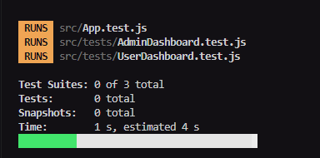

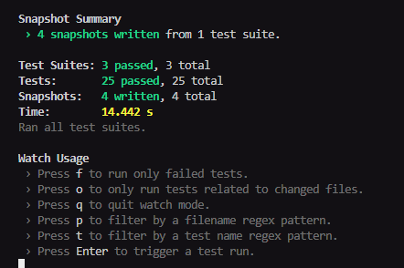
Initial Snapshots

App.test.js.snap

// Jest Snapshot v1, https://goo.gl/fbAQLP

exports[`App Routing matches snapshot for AdminDashboard 1`] = `
<DocumentFragment>
<div>
Admin Dashboard
</div>
</DocumentFragment>
`;

exports[`App Routing matches snapshot for Login page 1`] = `
<DocumentFragment>
<div>
Login
</div>
</DocumentFragment>
`;

exports[`App Routing matches snapshot for Register page 1`] = `
<DocumentFragment>
<div>
Register
</div>
</DocumentFragment>
`;

exports[`App Routing matches snapshot for UserDashboard 1`] = `
<DocumentFragment>
<div>
User Dashboard
</div>
</DocumentFragment>
`;
Snapshot Updations

Initial

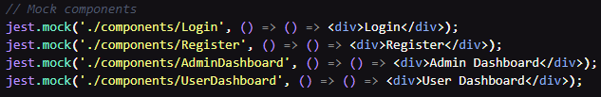

Update

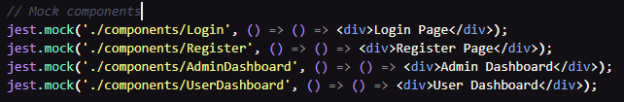

Diff of the mismatch to the initial snapshot

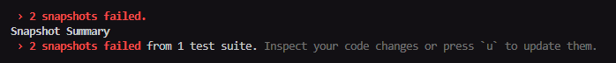

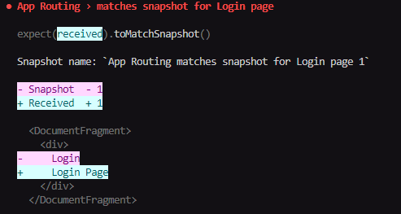

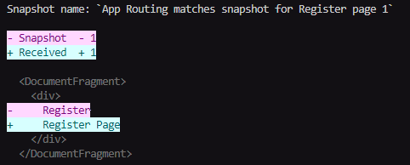
Snapshot Updating

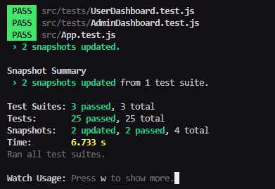

Reflection in the snapshot

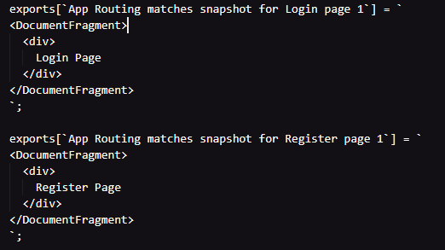
App.test.js

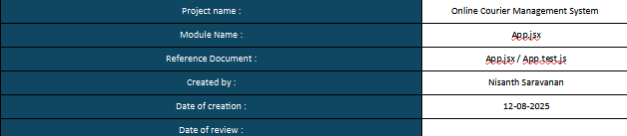

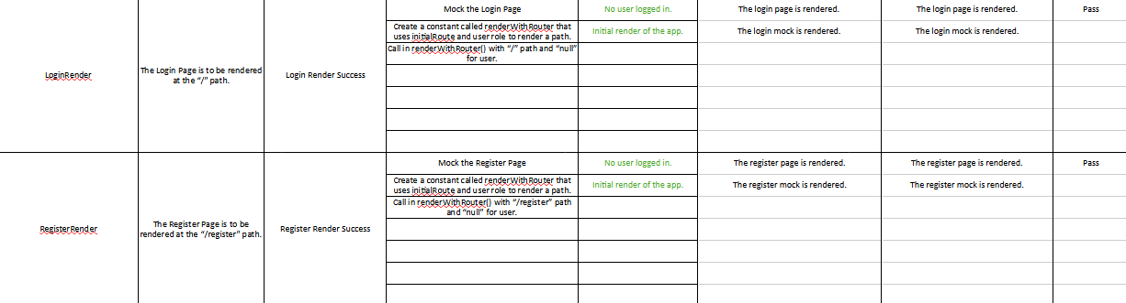
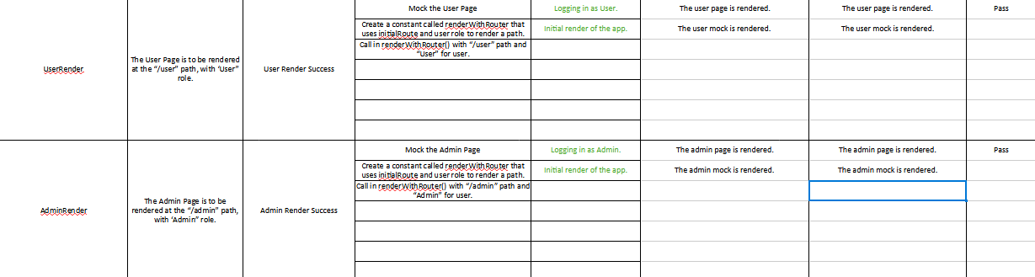

//App.test.js
import React from 'react';
import { render, screen } from '@testing-library/react';
import App from './App';
import { AuthContext } from './context/AuthContext';

// Mock components
jest.mock('./components/Login', () => () => <div>Login</div>);
jest.mock('./components/Register', () => () => <div>Register</div>);
jest.mock('./components/AdminDashboard', () => () => <div>Admin Dashboard</div>);
jest.mock('./components/UserDashboard', () => () => <div>User Dashboard</div>);

describe('App Routing', () => {
const renderWithRouter = (initialRoute, user) => {
window.history.pushState({}, 'Test page', initialRoute);

return render(
<AuthContext.Provider value={{ user }}>
<App />
</AuthContext.Provider>
);
};

it('renders Login page at root route', () => {
renderWithRouter('/', null);
expect(screen.getByText(/Login/i)).toBeInTheDocument();
});

it('renders Register page at /register', () => {
renderWithRouter('/register', null);
expect(screen.getByText(/Register/i)).toBeInTheDocument();
});

it('renders AdminDashboard for admin user', () => {
renderWithRouter('/admin', { role: 'Admin' });
expect(screen.getByText(/Admin Dashboard/i)).toBeInTheDocument();
});

it('redirects to Login if non-admin user accesses /admin', () => {
renderWithRouter('/admin', { role: 'User' });
expect(screen.getByText(/Login/i)).toBeInTheDocument();
});

it('renders UserDashboard for user role', () => {
renderWithRouter('/user', { role: 'User' });
expect(screen.getByText(/User Dashboard/i)).toBeInTheDocument();
});

it('redirects to Login if non-user accesses /user', () => {
renderWithRouter('/user', { role: 'Admin' });
expect(screen.getByText(/Login/i)).toBeInTheDocument();
});

it('matches snapshot for Login page', () => {
const { asFragment } = renderWithRouter('/', null);
expect(asFragment()).toMatchSnapshot();
});

it('matches snapshot for Register page', () => {
const { asFragment } = renderWithRouter('/register', null);
expect(asFragment()).toMatchSnapshot();
});

it('matches snapshot for AdminDashboard', () => {
const { asFragment } = renderWithRouter('/admin', { role: 'Admin' });
expect(asFragment()).toMatchSnapshot();
});

it('matches snapshot for UserDashboard', () => {
const { asFragment } = renderWithRouter('/user', { role: 'User' });
expect(asFragment()).toMatchSnapshot();
});
});

UserDashboard.test.js

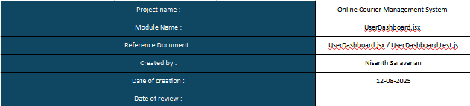

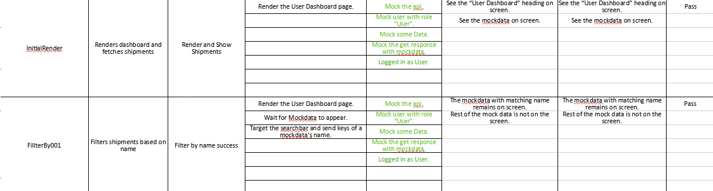
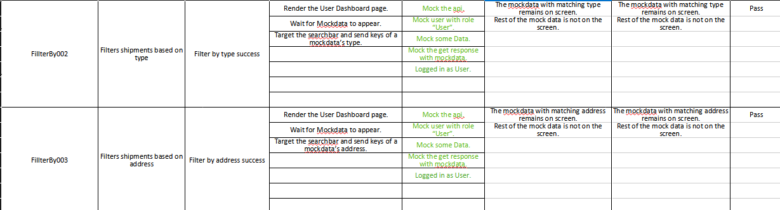
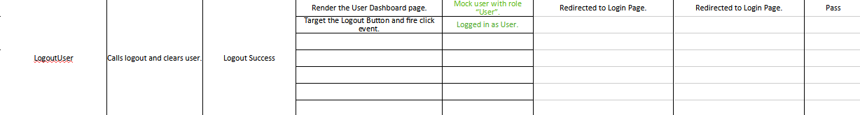

//User test
import React from 'react';
import { render, screen, fireEvent, waitFor, act } from '@testing-library/react';
import { AuthContext } from '../context/AuthContext';
import { MemoryRouter } from 'react-router-dom';
import UserDashboard from '../components/UserDashboard';
import API from '../services/api';

jest.mock('../services/api');

const mockUser = { role: 'user' };
const mockSetUser = jest.fn();

const mockShipments = [
{ id: 1, name: 'Box A', type: 'Electronics', address: '123 Street' },
{ id: 2, name: 'Box B', type: 'Clothing', address: '456 Avenue' },
];

describe('UserDashboard', () => {
beforeEach(() => {
API.get.mockResolvedValue({ data: mockShipments });
});

it('renders dashboard and fetches shipments', async () => {
await act(async () => {
render(
<MemoryRouter>
<AuthContext.Provider value={{ user: mockUser, setUser: mockSetUser }}>
<UserDashboard />
</AuthContext.Provider>
</MemoryRouter>
);
});

expect(screen.getByText(/User Dashboard/i)).toBeInTheDocument();

await waitFor(() => {
expect(screen.getByText(/Box A/i)).toBeInTheDocument();
expect(screen.getByText(/Box B/i)).toBeInTheDocument();
});
});

it('filters shipments based on name', async () => {
await act(async () => {
render(
<MemoryRouter>
<AuthContext.Provider value={{ user: mockUser, setUser: mockSetUser }}>
<UserDashboard />
</AuthContext.Provider>
</MemoryRouter>
);
});

await waitFor(() => screen.getByText(/Box A/i));

act(() => {
fireEvent.change(screen.getByPlaceholderText(/Search by name/i), {
target: { value: 'Box A' },
});
});

expect(screen.queryByText(/Box B/i)).not.toBeInTheDocument();
expect(screen.getByText(/Box A/i)).toBeInTheDocument();
});

it('filters shipments based on type', async () => {
await act(async () => {
render(
<MemoryRouter>
<AuthContext.Provider value={{ user: mockUser, setUser: mockSetUser }}>
<UserDashboard />
</AuthContext.Provider>
</MemoryRouter>
);
});

await waitFor(() => screen.getByText(/Box A/i));

act(() => {
fireEvent.change(screen.getByPlaceholderText(/Search by name/i), {
target: { value: 'Electronics' },
});
});

expect(screen.queryByText(/Box B/i)).not.toBeInTheDocument();
expect(screen.getByText(/Box A/i)).toBeInTheDocument();
});

it('filters shipments based on address', async () => {
await act(async () => {
render(
<MemoryRouter>
<AuthContext.Provider value={{ user: mockUser, setUser: mockSetUser }}>
<UserDashboard />
</AuthContext.Provider>
</MemoryRouter>
);
});

await waitFor(() => screen.getByText(/Box A/i));

act(() => {
fireEvent.change(screen.getByPlaceholderText(/Search by name/i), {
target: { value: '123 Street' },
});
});

expect(screen.queryByText(/Box B/i)).not.toBeInTheDocument();
expect(screen.getByText(/Box A/i)).toBeInTheDocument();
});

it('calls logout and clears user', async () => {
await act(async () => {
render(
<MemoryRouter>
<AuthContext.Provider value={{ user: mockUser, setUser: mockSetUser }}>
<UserDashboard />
</AuthContext.Provider>
</MemoryRouter>
);
});

act(() => {
fireEvent.click(screen.getByText(/Logout/i));
});

expect(mockSetUser).toHaveBeenCalledWith(null);
});
});

AdminDashboard.test.js

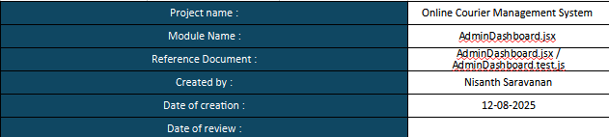

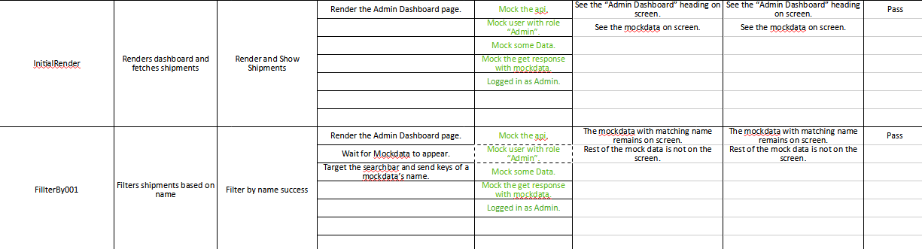
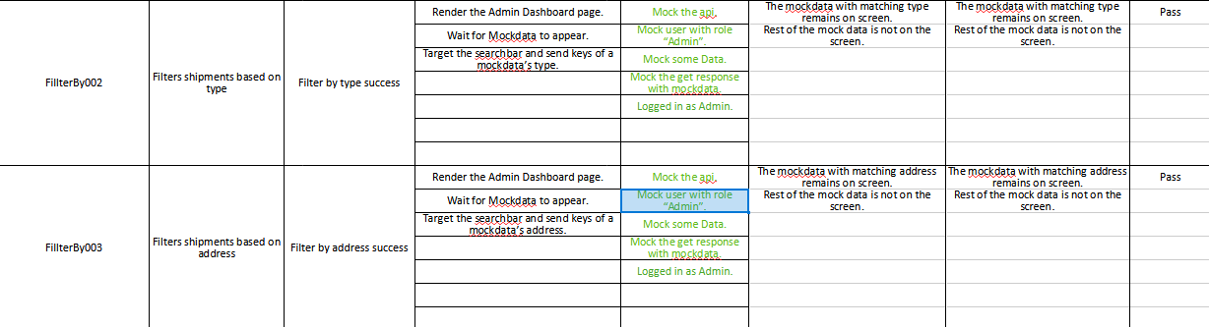
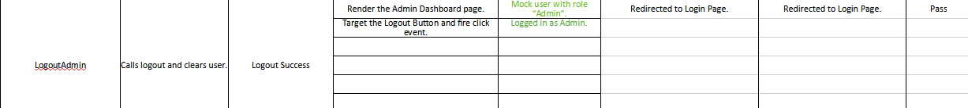
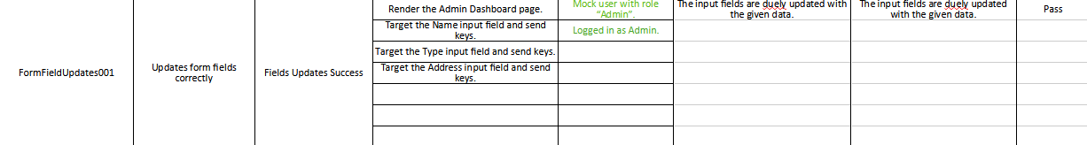
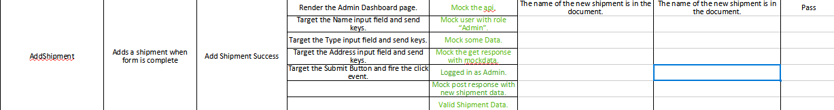
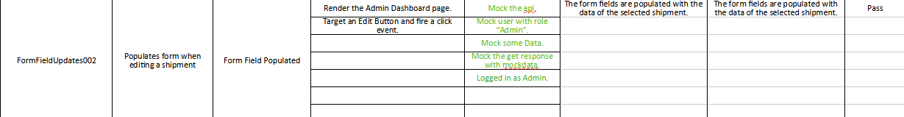
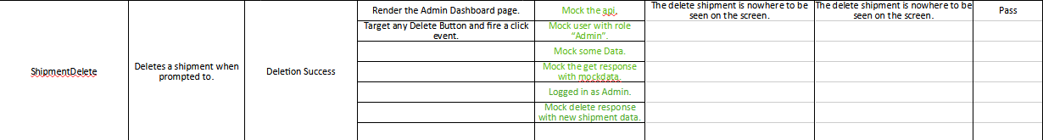
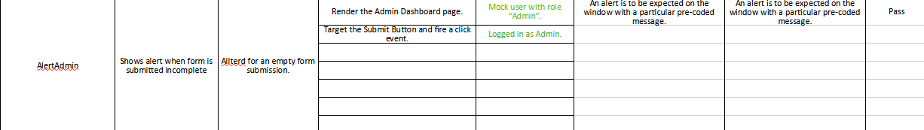

//Admin Test
import React from 'react';
import { render, screen, fireEvent, waitFor, act } from '@testing-library/react';
import { AuthContext } from '../context/AuthContext';
import { MemoryRouter } from 'react-router-dom';
import AdminDashboard from '../components/AdminDashboard';
import API from '../services/api';

jest.mock('../services/api');

const mockUser = { role: 'admin' };
const mockSetUser = jest.fn();

const mockShipments = [
{ id: 1, name: 'Box A', type: 'Electronics', address: '123 Street' },
{ id: 2, name: 'Box B', type: 'Clothing', address: '456 Avenue' },
];

describe('AdminDashboard', () => {
beforeEach(() => {
API.get.mockResolvedValue({ data: mockShipments });
});

it('renders dashboard and fetches shipments', async () => {
await act(async () => {
render(
<MemoryRouter>
<AuthContext.Provider value={{ user: mockUser, setUser: mockSetUser }}>
<AdminDashboard />
</AuthContext.Provider>
</MemoryRouter>
);
});

expect(screen.getByText(/Admin Dashboard/i)).toBeInTheDocument();

await waitFor(() => {
expect(screen.getByText(/Box A/i)).toBeInTheDocument();
expect(screen.getByText(/Box B/i)).toBeInTheDocument();
});
});

it('filters shipments based on name', async () => {
await act(async () => {
render(
<MemoryRouter>
<AuthContext.Provider value={{ user: mockUser, setUser: mockSetUser }}>
<AdminDashboard />
</AuthContext.Provider>
</MemoryRouter>
);
});

await waitFor(() => screen.getByText(/Box A/i));

act(() => {
fireEvent.change(screen.getByPlaceholderText(/Search by name/i), {
target: { value: 'Box A' },
});
});

expect(screen.queryByText(/Box B/i)).not.toBeInTheDocument();
expect(screen.getByText(/Box A/i)).toBeInTheDocument();
});

it('filters shipments based on type', async () => {
await act(async () => {
render(
<MemoryRouter>
<AuthContext.Provider value={{ user: mockUser, setUser: mockSetUser }}>
<AdminDashboard />
</AuthContext.Provider>
</MemoryRouter>
);
});

await waitFor(() => screen.getByText(/Box A/i));

act(() => {
fireEvent.change(screen.getByPlaceholderText(/Search by name/i), {
target: { value: 'Electronics' },
});
});

expect(screen.queryByText(/Box B/i)).not.toBeInTheDocument();
expect(screen.getByText(/Box A/i)).toBeInTheDocument();
});

it('filters shipments based on address', async () => {
await act(async () => {
render(
<MemoryRouter>
<AuthContext.Provider value={{ user: mockUser, setUser: mockSetUser }}>
<AdminDashboard />
</AuthContext.Provider>
</MemoryRouter>
);
});

await waitFor(() => screen.getByText(/Box A/i));

act(() => {
fireEvent.change(screen.getByPlaceholderText(/Search by name/i), {
target: { value: '123 Street' },
});
});

expect(screen.queryByText(/Box B/i)).not.toBeInTheDocument();
expect(screen.getByText(/Box A/i)).toBeInTheDocument();
});

it('calls logout and clears user', async () => {
await act(async () => {
render(
<MemoryRouter>
<AuthContext.Provider value={{ user: mockUser, setUser: mockSetUser }}>
<AdminDashboard />
</AuthContext.Provider>
</MemoryRouter>
);
});

act(() => {
fireEvent.click(screen.getByText(/Logout/i));
});

expect(mockSetUser).toHaveBeenCalledWith(null);
});

it('updates form fields correctly', async () => {
await act(async () => {
render(
<MemoryRouter>
<AuthContext.Provider value={{ user: mockUser, setUser: mockSetUser }}>
<AdminDashboard />
</AuthContext.Provider>
</MemoryRouter>
);
});

fireEvent.change(screen.getByPlaceholderText('Name'), {
target: { value: 'New Shipment' },
});
fireEvent.change(screen.getByPlaceholderText('Type'), {
target: { value: 'Books' },
});
fireEvent.change(screen.getByPlaceholderText('Address'), {
target: { value: '789 Boulevard' },
});

expect(screen.getByPlaceholderText('Name').value).toBe('New Shipment');
expect(screen.getByPlaceholderText('Type').value).toBe('Books');
expect(screen.getByPlaceholderText('Address').value).toBe('789 Boulevard');
});

it('adds a shipment when form is complete', async () => {
const newShipment = { id: 3, name: 'Box C', type: 'Books', address: '789 Boulevard' };

// Initial fetch: Box A and Box B
API.get.mockResolvedValueOnce({ data: mockShipments });

// Mock POST response
API.post.mockResolvedValue({ data: newShipment });

// After adding: Box A, Box B, and Box C
API.get.mockResolvedValueOnce({ data: [...mockShipments, newShipment] });

await act(async () => {
render(
<MemoryRouter>
<AuthContext.Provider value={{ user: mockUser, setUser: mockSetUser }}>
<AdminDashboard />
</AuthContext.Provider>
</MemoryRouter>
);
});

// Fill form
fireEvent.change(screen.getByPlaceholderText('Name'), {
target: { value: 'Box C' },
});
fireEvent.change(screen.getByPlaceholderText('Type'), {
target: { value: 'Books' },
});
fireEvent.change(screen.getByPlaceholderText('Address'), {
target: { value: '789 Boulevard' },
});

// Submit form
await act(async () => {
fireEvent.click(screen.getByText(/Add Shipment/i));
});

// Wait for re-render with new shipment
await waitFor(() => {
expect(screen.getByText(/Box C/i)).toBeInTheDocument();
});
});

it('populates form when editing a shipment', async () => {
await act(async () => {
render(
<MemoryRouter>
<AuthContext.Provider value={{ user: mockUser, setUser: mockSetUser }}>
<AdminDashboard />
</AuthContext.Provider>
</MemoryRouter>
);
});

await waitFor(() => screen.getByText(/Box A/i));

fireEvent.click(screen.getAllByText(/Edit/i)[0]);

expect(screen.getByPlaceholderText('Name').value).toBe('Box A');
expect(screen.getByPlaceholderText('Type').value).toBe('Electronics');
expect(screen.getByPlaceholderText('Address').value).toBe('123 Street');
});

it('deletes a shipment', async () => {
// Initial mock: both shipments
API.get.mockResolvedValueOnce({ data: mockShipments });

// Mock delete response
API.delete.mockResolvedValue({});

// After deletion: only Box B remains
API.get.mockResolvedValueOnce({ data: [mockShipments[1]] });

await act(async () => {
render(
<MemoryRouter>
<AuthContext.Provider value={{ user: mockUser, setUser: mockSetUser }}>
<AdminDashboard />
</AuthContext.Provider>
</MemoryRouter>
);
});

// Wait for initial render
await waitFor(() => {
expect(screen.getByText(/Box A/i)).toBeInTheDocument();
});

// Trigger delete
await act(async () => {
fireEvent.click(screen.getAllByText(/Delete/i)[0]);
});

// Wait for re-render after deletion
await waitFor(() => {
expect(screen.queryByText(/Box A/i)).not.toBeInTheDocument();
expect(screen.getByText(/Box B/i)).toBeInTheDocument();
});
});

it('shows alert when form is incomplete', async () => {
window.alert = jest.fn();

await act(async () => {
render(
<MemoryRouter>
<AuthContext.Provider value={{ user: mockUser, setUser: mockSetUser }}>
<AdminDashboard />
</AuthContext.Provider>
</MemoryRouter>
);
});

act(() => {
fireEvent.click(screen.getByText(/Add Shipment/i));
});

expect(window.alert).toHaveBeenCalledWith('All fields Needed!');
});
});

Code Base

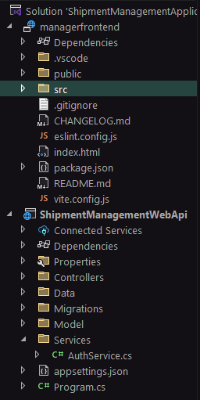
Backend:

/Services/AuthService.cs

using ShipmentManagementWebApi.Data;
using ShipmentManagementWebApi.Models;
using Microsoft.EntityFrameworkCore;

namespace ShipmentManagementWebApi.Services;

public class AuthService
{
private readonly AppDbContext _context;

public AuthService(AppDbContext context)
{
_context = context;
}

public User Authenticate(string username, string password)
{
return _context.Users.FirstOrDefault(u => u.Username == username && u.Password == password);
}

public bool Register(User user)
{
if (_context.Users.Any(u => u.Username == user.Username)) return false;
_context.Users.Add(user);
_context.SaveChanges();
return true;
}
}

appsettings.json

{
"Logging": {
"LogLevel": {
"Default": "Information",
"Microsoft.AspNetCore": "Warning"
}
},
"ConnectionStrings": {
"DefaultConnection": "Server=127.0.0.1;Port=3306;Database=ShipmentDb;User=root;Password=root"
},
"AllowedHosts": "*"
}

Program.cs

using Microsoft.EntityFrameworkCore;
using ShipmentManagementWebApi.Data;
using ShipmentManagementWebApi.Services;

var builder = WebApplication.CreateBuilder(args);

// Add services to the container.

builder.Services.AddControllers();
// Learn more about configuring Swagger/OpenAPI at https://aka.ms/aspnetcore/swashbuckle
builder.Services.AddEndpointsApiExplorer();
builder.Services.AddSwaggerGen();

// Configure EF Core with MySQL
builder.Services.AddDbContext<AppDbContext>(options =>
options.UseMySql(
builder.Configuration.GetConnectionString("DefaultConnection"),
ServerVersion.AutoDetect(builder.Configuration.GetConnectionString("DefaultConnection"))
));

// Register custom services
builder.Services.AddScoped<AuthService>();

builder.Services.AddCors(options =>
{
options.AddPolicy("AllowReactApp",
policy => policy
.WithOrigins("http://localhost:51097") // React dev server
.AllowAnyHeader()
.AllowAnyMethod());
});

var app = builder.Build();

app.UseCors("AllowReactApp");

// Configure the HTTP request pipeline.
if (app.Environment.IsDevelopment())
{
app.UseSwagger();
app.UseSwaggerUI();
}

app.UseHttpsRedirection();

app.UseAuthorization();

app.MapControllers();

app.Run();

/Models/User.cs

using System.ComponentModel.DataAnnotations;

namespace ShipmentManagementWebApi.Models
{
public class User
{
[Key]
public int Id { get; set; }
public string? Username { get; set; }
public string? Password { get; set; } // Plain text for simplicity
public string? Role { get; set; } = "User"; // Default role
}

}

/Models/Shipment.cs

using System.ComponentModel.DataAnnotations;

namespace ShipmentManagementWebApi.Models
{
public class Shipment
{
[Key]
public int Id { get; set; }
public string? Name { get; set; }
public string? Type { get; set; }
public string? Address { get; set; }
}
}

/Data/AppDbContext.cs

using Microsoft.EntityFrameworkCore;
using System.Collections.Generic;
using ShipmentManagementWebApi.Models;

namespace ShipmentManagementWebApi.Data
{
public class AppDbContext : DbContext
{
public AppDbContext(DbContextOptions<AppDbContext> options) : base(options) { }

public DbSet<User> Users { get; set; }
public DbSet<Shipment> Shipments { get; set; }

}
}

/Controllers/AuthController.cs

using Microsoft.AspNetCore.Mvc;
using ShipmentManagementWebApi.Services;
using ShipmentManagementWebApi.Models;

[ApiController]
[Route("api/[controller]")]
public class AuthController : ControllerBase
{
private readonly AuthService _authService;

public AuthController(AuthService authService)
{
_authService = authService;
}

[HttpPost("register")]
public IActionResult Register(User user)
{
user.Role = "User"; // Default role
if (_authService.Register(user)) return Ok("Registered successfully");
return BadRequest("Username already exists");
}

[HttpPost("login")]
public IActionResult Login(User user)
{
var loggedInUser = _authService.Authenticate(user.Username, user.Password);
if (loggedInUser == null) return Unauthorized("Invalid credentials");
return Ok(loggedInUser); // Return user object with role
}
}

/Controllers/ShipmentController.cs

using Microsoft.AspNetCore.Mvc;
using ShipmentManagementWebApi.Data;
using ShipmentManagementWebApi.Models;

[ApiController]
[Route("api/[controller]")]
public class ShipmentController : ControllerBase
{
private readonly AppDbContext _context;

public ShipmentController(AppDbContext context)
{
_context = context;
}

[HttpGet]
public IActionResult GetAll() => Ok(_context.Shipments.ToList());

[HttpGet("{id}")]
public IActionResult Get(int id)
{
var shipment = _context.Shipments.Find(id);
if (shipment == null) return NotFound();
return Ok(shipment);
}

[HttpPost]
public IActionResult Create(Shipment shipment, [FromQuery] string role)
{
if (role != "Admin") return Unauthorized("Only admin can create shipments");
_context.Shipments.Add(shipment);
_context.SaveChanges();
return Ok(shipment);
}

[HttpPut("{id}")]
public IActionResult Update(int id, Shipment updatedshipment, [FromQuery] string role)
{
if (role != "Admin") return Unauthorized("Only admin can update shipments");
var shipment = _context.Shipments.Find(id);
if (shipment == null) return NotFound();

shipment.Name = updatedshipment.Name;
shipment.Type = updatedshipment.Type;
shipment.Address = updatedshipment.Address;

_context.SaveChanges();
return Ok(shipment);
}

[HttpDelete("{id}")]
public IActionResult Delete(int id, [FromQuery] string role)
{
if (role != "Admin") return Unauthorized("Only admin can delete shipments");
var shipment = _context.Shipments.Find(id);
if (shipment == null) return NotFound();

_context.Shipments.Remove(shipment);
_context.SaveChanges();
return Ok("Deleted");
}
}

Frontend – React JS

/src/main.jsx

import React from 'react';
import ReactDOM from 'react-dom/client';
import App from './App';
import { AuthProvider } from './context/AuthContext';
import "./index.css";

const root = ReactDOM.createRoot(document.getElementById('root'));
root.render(
<AuthProvider>
<App />
</AuthProvider>
);

/src/App.jsx

import React, { useContext } from 'react';
import { BrowserRouter as Router, Routes, Route, Navigate } from 'react-router-dom';
import Login from './components/Login';
import Register from './components/Register';
import AdminDashboard from './components/AdminDashboard';
import UserDashboard from './components/UserDashboard';
import { AuthContext } from './context/AuthContext';
import "./App.css";

function App() {
const { user } = useContext(AuthContext);

return (
<Router>
<Routes>
<Route path="/" element={<Login />} />
<Route path="/register" element={<Register />} />
<Route path="/admin" element={user?.role === 'Admin' ? <AdminDashboard /> : <Navigate to="/" />} />
<Route path="/user" element={user?.role === 'User' ? <UserDashboard /> : <Navigate to="/" />} />
</Routes>
</Router>
);
}

export default App;

/services/api.js

//api.js
import axios from 'axios';

const API = axios.create({
baseURL: 'http://localhost:5099/api', // Adjust if needed
});

export default API;

/context/AuthContext.jsx

//AuthContext.jsx
import React, { createContext, useState } from 'react';

// eslint-disable-next-line react-refresh/only-export-components
export const AuthContext = createContext();

export const AuthProvider = ({ children }) => {
const [user, setUser] = useState(null); // Holds logged-in user

return (
<AuthContext.Provider value={{ user, setUser }}>
{children}
</AuthContext.Provider>
);
};

/components/Login.jsx

import React, { useState, useContext, useEffect } from 'react';
import { useNavigate } from 'react-router-dom';
import API from '../services/api';
import { AuthContext } from '../context/AuthContext';

function Login() {
const [username, setUsername] = useState('');
const [password, setPassword] = useState('');
const { setUser } = useContext(AuthContext);
const { user } = useContext(AuthContext);
const navigate = useNavigate();

const handleLogin = async () => {

if (username == '' || password == '') {
alert("All credentials are mandatory.");
return;
}

try {
const res = await API.post('/auth/login', { username, password });
setUser(res.data);
res.data.role === 'Admin' ? navigate('/admin') : navigate('/user');
} catch {
alert('Invalid credentials');
}
};

const handleRegister = () => {
navigate('/register');
}

useEffect(() => {
document.title = "Login";

if (user?.role == "Admin") {
navigate("/admin");
}
else if (user?.role == "User") {
navigate("/user")
}
});

return (
<>
<div class="container">
<h2>Login</h2>
<table>
<tr>
<td>
<div class="input-group input-group-lg mb-3">
<input class="form-control" placeholder="Username" onChange={e => setUsername(e.target.value)} />
</div>
</td>
</tr>
<tr>
<td>
<div class="input-group input-group-lg mb-3">
<input class="form-control" placeholder="Password" type="password" onChange={e => setPassword(e.target.value)} />
</div>
</td>
</tr>
<tr>
<td>
<button onClick={handleLogin}>Login</button>
</td>
</tr>
<br></br>
<tr>
<td>
<button onClick={handleRegister}>New User? Register.</button>
</td>
</tr>
</table>
</div>
</>
);
}

export default Login;

/components/Register.jsx

import React, { useState, useEffect, useContext } from 'react';
import { useNavigate } from 'react-router-dom';
import API from '../services/api';
import { AuthContext } from '../context/AuthContext';

function Register() {
const [username, setUsername] = useState('');
const [password, setPassword] = useState('');
const { user } = useContext(AuthContext);
const navigate = useNavigate();

const handleRegister = async () => {

if (username == '' || password == '') {
alert("All credentials are mandatory.");
return;
}

try {
await API.post('/auth/register', { username, password });
alert('Registration successful');
navigate("/");
} catch {
alert('Registration failed');
}
};

const handleLogin= () => {
navigate('/');
}

useEffect(() => {
document.title = "Register";

if (user?.role == "Admin") {
navigate("/admin");
}
else if (user?.role == "User") {
navigate("/user")
}
});

return (
<>
<div class="container">
<h2>Register</h2>
<table>
<tr>
<td>
<div class="input-group input-group-lg mb-3">
<input class="form-control" placeholder="Username" onChange={e => setUsername(e.target.value)} />
</div>
</td>
</tr>
<tr>
<td>
<div class="input-group input-group-lg mb-3">
<input class="form-control" placeholder="Password" type="password" onChange={e => setPassword(e.target.value)} />
</div>
</td>
</tr>
<tr>
<td>
<button onClick={handleRegister}>Register</button>
</td>
</tr>
<br></br>
<tr>
<td>
<button onClick={handleLogin}>Old User? Login.</button>
</td>
</tr>
</table>
</div>
</>
);
}

export default Register;

/components/AdminDashboard.jsx

import React, { useContext, useEffect, useState } from 'react';
import API from '../services/api';
import { AuthContext } from '../context/AuthContext';

function AdminDashboard() {
const { user } = useContext(AuthContext);
const [shipments, setShipment] = useState([]);
const { setUser } = useContext(AuthContext);
const [searchTerm, setSearchTerm] = useState('');
const [form, setForm] = useState({ name: '', type: '', address: ''});
const [editingId, setEditingId] = useState(null);

const fetchShipments = async () => {
const res = await API.get('/shipment');
setShipment(res.data);
};

const createOrUpdateShipment = async () => {

if (form.name == '' || form.type == '' || form.address == '') {
alert("All fields Needed!");
return;
}

if (editingId) {
await API.put(`/shipment/${editingId}?role=${user.role}`, form);
setEditingId(null);
} else {
await API.post(`/shipment?role=${user.role}`, form);
}
setForm({ name: '', type: '', address: '' });
fetchShipments();
};

const deleteShipment = async (id) => {
await API.delete(`/shipment/${id}?role=${user.role}`);
fetchShipments();
};

const startEdit = (shipment) => {
setForm(shipment);
setEditingId(shipment.id);
};

const filteredShipments = shipments.filter(s =>
s.name.toLowerCase().includes(searchTerm.toLowerCase()) ||
s.type.toLowerCase().includes(searchTerm.toLowerCase()) ||
s.address.toString().includes(searchTerm)
);

const logout = () => {
setUser(null);
};

useEffect(() => {
document.title = "Admin Dash";

fetchShipments();
}, []);

return (
<div class="container">
<h2>Admin Dashboard</h2>
<br></br>
<button onClick={logout} style={{ marginBottom: '1rem' }}>
Logout
</button>
<br></br>
<br></br>
<table>
<tr>
<td>
<div class="input-group input-group-lg mb-3">
<input class="form-control" placeholder="Name" value={form.name} onChange={e => setForm({ ...form, name: e.target.value })} />
</div>
</td>
</tr>
<tr>
<td>
<div class="input-group input-group-lg mb-3">
<input class="form-control" placeholder="Type" value={form.type} onChange={e => setForm({ ...form, type: e.target.value })} />
</div>
</td>
</tr>
<tr>
<td>
<div class="input-group input-group-lg mb-3">
<input class="form-control" placeholder="Address" value={form.address} onChange={e => setForm({ ...form, address: e.target.value })} />
</div>
</td>
</tr>
<tr>
<td>
<button onClick={createOrUpdateShipment}>
{editingId ? 'Update Shipment' : 'Add Shipment'}
</button>
</td>
</tr>
<br></br>
<br></br>
<br></br>
<tr>
<td>
<input
class="form-control"
placeholder="Search by name, type, or address"
value={searchTerm}
onChange={e => setSearchTerm(e.target.value)}
/>
</td>
</tr>
</table>
<ul>
{filteredShipments.map(s => (
<li key={s.id}>
<strong>Name:</strong> {s.name},&nbsp;&nbsp;&nbsp;&nbsp; <strong>Type:</strong> {s.type},&nbsp;&nbsp;&nbsp;&nbsp; <strong>Addressed To:</strong> {s.address} &nbsp;&nbsp;&nbsp;&nbsp;
<button onClick={() => startEdit(s)}>Edit</button> &nbsp;&nbsp;&nbsp;&nbsp;
<button onClick={() => deleteShipment(s.id)}>Delete</button>
</li>
))}
</ul>
</div>
);
}

export default AdminDashboard;

/components/UserDashboard.jsx

import React, { useContext, useEffect, useState } from 'react';
import API from '../services/api';
import { AuthContext } from '../context/AuthContext';

function UserDashboard() {
const [shipments, setShipment] = useState([]);
const [searchTerm, setSearchTerm] = useState('');
const { setUser } = useContext(AuthContext);

useEffect(() => {
document.title = "User Dash";

API.get('/shipment').then(res => setShipment(res.data));
}, []);

const logout = () => {
setUser(null);
};

const filteredShipments = shipments.filter(s =>
s.name.toLowerCase().includes(searchTerm.toLowerCase()) ||
s.type.toLowerCase().includes(searchTerm.toLowerCase()) ||
s.address.toString().includes(searchTerm)
);

return (
<div class="container">
<h2>User Dashboard</h2>
<br></br>
<button onClick={logout} style={{ marginBottom: '1rem' }}>
Logout
</button>
<br></br>
<br></br>
<table>
<tr>
<td>
<input
class="form-control"
placeholder="Search by name, type, or address"
value={searchTerm}
onChange={e => setSearchTerm(e.target.value)}
/>
</td>
</tr>
</table>
<br></br>
<br></br>
<ul>
{filteredShipments.map(s => (
<li key={s.id}>
<strong>Name:</strong> {s.name},&nbsp;&nbsp;&nbsp;&nbsp; <strong>Type:</strong> {s.type},&nbsp;&nbsp;&nbsp;&nbsp; <strong>Addressed To:</strong> {s.address} &nbsp;&nbsp;&nbsp;&nbsp;
</li>
))}
</ul>
</div>
);
}

export default UserDashboard;

